

**National University**



of Computer

and

Emerging Sciences

Chiniot

-

Faisalabad Campus



**EE1005 – Digital Logic and Design**

**Instructor:** Muhammad Adeel Tahir

**Sections:** BSE-2B

**Time:** 30 Minutes

**Name**

**Roll No.**

1. Convert the signed **(9AB)16** to octal equivalent and determine whether it is a positive number or a negative number

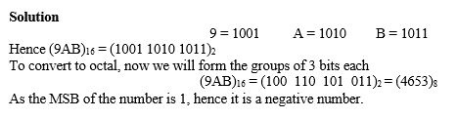

1. Two signed numbers are given as:

A = **(41)10**  and B = **(33)16**

1. Compute A – B in binary by using 2’s complement method.
2. Verify that your answer is correct.
3. Multiply A with (101)2 and verify that your answer is correct.

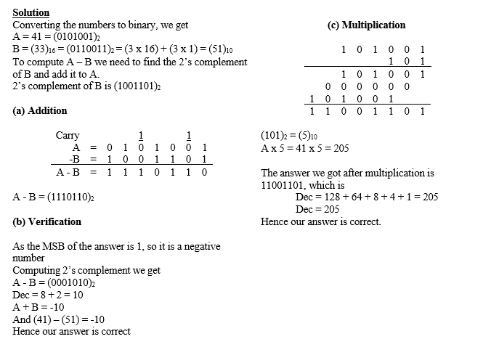

1. Determine the minimum number of bits required to code 150 combinations.

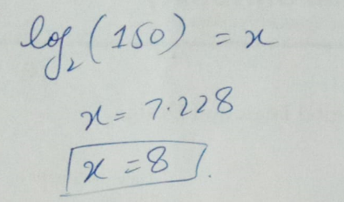

1. Formulate a 4-bit weighted binary code using weights 8, 4, 2, and 1 for the decimal digits.

